Assignment No .2 Questions

Picture 1:

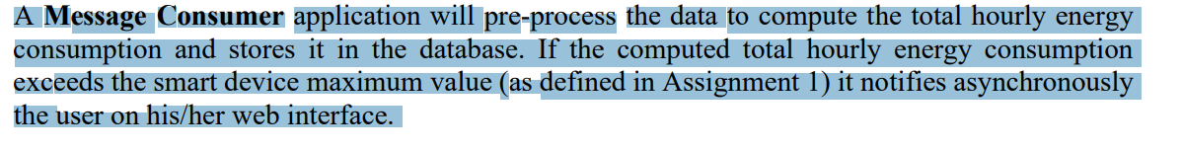

1. If Sensor Simulator takes 1 record every 10 mints than after   
   Means after 1 hours = 60mints it will be 6 Entries Ok  
   Than we will sum of all entries and show in barchart right ?
2. Question .2 is : The values in CSV is only Watt or KiloWattHour

Diagram of Complete Flow : Need confirmation

